To,
The Professor & Head,
Institute of Animal Nutrition
Kattupakkam, Chengalpattu District,
Tamil Nadu 603203.
Subject: Performance Certificates
Respected Sir,
We, NIHVA Technologies Pvt.Ltd. have maintain a good record and always strive to deliver our best. We believe in customer satisfaction. Following are few appreciation letters from our customers.

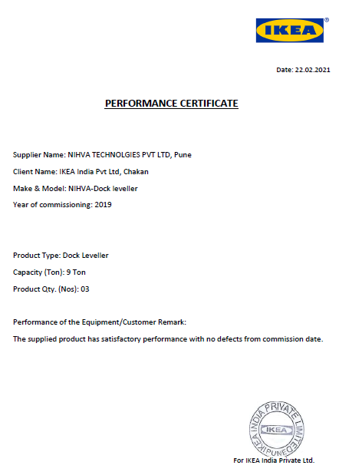
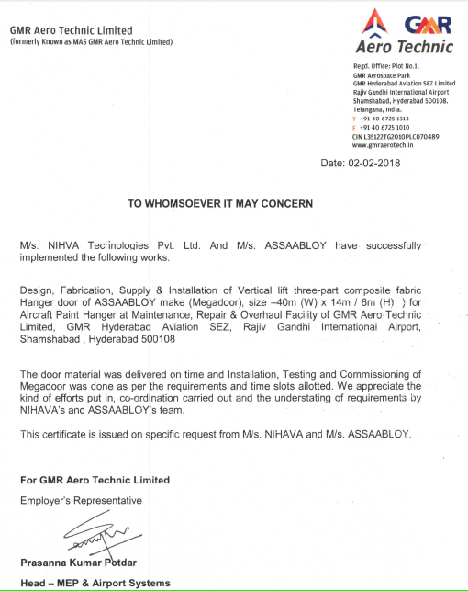

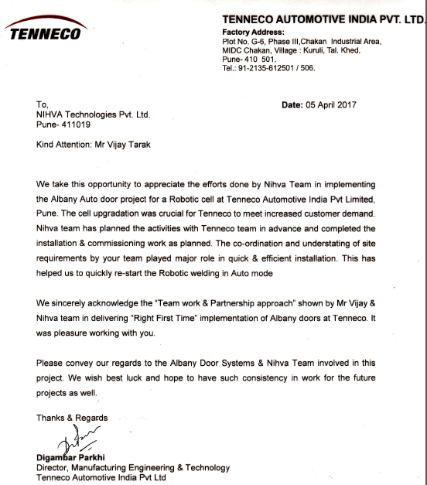

Thanks & Regards,
NIHVA Technologies Pvt.Ltd.
187, First floor, G Block, Thermax Chowk,
MIDC, Pimpri-Chinchwad, Pune 411019
Maharashtra 411019.

